# Data Source and data sets

## WorldBank Data:

<https://data.worldbank.org/indicator/IS.AIR.PSGR?end=2020&start=1970&view=chart>

Raw data file name:

1. API_IS.AIR.PSGR_DS2_en_csv_v2_4499051.csv

Power BI Query Name:

1. WorldBankAirTransportPassengers

## Aviation Safety Network Data:

<https://www.geckoboard.com/blog/6-data-visualization-techniques-to-display-your-key-metrics/>

Raw data file name:

1. airline-safety.csv
2. table_02_14_102521.xlsx
3. table_02_09_102621.xlsx

Power BI Query Name:

1. airline-safety
2. US General Aviation Safety Data
3. US Air Carrier Safety Data

## AirlinePassengerSatisfaction Data (New for Milestone 4)

<https://www.kaggle.com/datasets/teejmahal20/airline-passenger-satisfaction>

Raw data file name:

AirlinePassengerSatisfaction.csv

Power BI Query Name:

AirlinePassengerSatisfaction

# Data transformations

airline-safety dataset did not need much transformation. It contains data for 56 international airlines. These airlines were in the global top 100 list as of 2012. Data shows incidents, fatal accidents and fatalities spanning 30 years starting from 1985 ending 2014. Data for each category is divided to 1985-1999 and 2000 to 2014. We added a new column to the table. The new Column, “Ranking” was calculated based on the value of available seat per week. Those with more than 2 million were ranked top, those between 1 and 2 million were ranked Middle and those below 1 million were ranked bottom.

US General Aviation Safety Data was transposed, filtered and transformed into a 10 column table. It has the fatalities and incident counts for all US airlines from 1970 to 2020.

WorldBankAirTransportPassengers dataset contained data for number of passengers traveled worldwide from 1960 to 2020. The data set has this data for every country in the world as well as a total for the world. We transformed the table to two columns-Year and Passenger traveled worldwide. We used this transformed table to create a metric for the presentation. The details of the metrics are described below.

US Air Carrier Safety Data dataset was reduced 9 columns. Column “Nonfatal accidents” was computed by subtracting Fatal accidents column from Total accident column.

AirlinePassengerSatisfaction (New for Milestone 4) rearranged columns, changed data types .

# Data Presentation Plan

Since we are presenting our case in an Infographic, we need to be put as much information in a small are such as a 8x11 poster, or single page on a website. We decided to use Adobe Illustrator. We created a 16x16 Artboard (an empty sheet) and arranged it as shown is the wireframe form below. As shown by the arrows, the flow of the presentation starts from the top of the page, and then 4 sections the present from left to right, down, left to right.

# Data Presentation

We made the background of the page baby blue to create a tranquil environment and remove any sense of alarm. The picture of ab airplane flying nicely in the blue sky emphasizes the tranquility. The red “Is Air Travel Safe” is an attention grabber to follow through the rest of the presentation. The second question is in white background and centered with smaller font and black. The four sections tell the story. The heatmaps show correlation, the stacked area chart shows 5 categories to discern information from. The two bottom sections show customer satisfaction in a bar chart and the map view shows the amount of travel worldwide, with the total number of flights for the entire 30 years. The resources have to be there of course to ascertain credibility of the presentation.

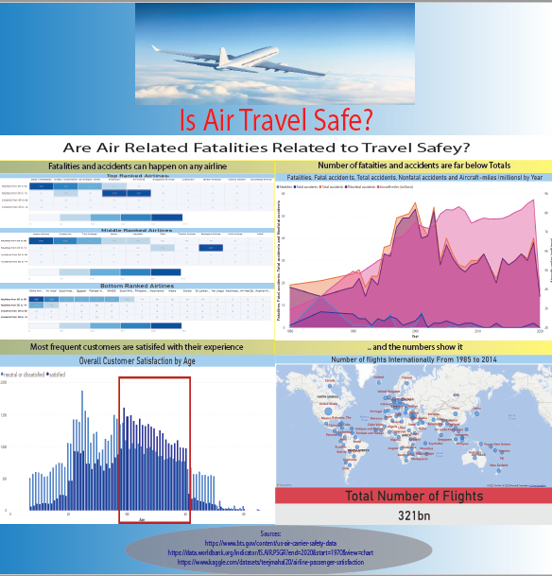

# Ethical considerations

None of the claims or opinions made in this presentation are accurate. They are only to satisfy a school assignment,